

LeadTrack App Standard Operating Procedure (SOP)

Word Document SOP

Introduction
The LeadTrack App is a mobile application designed for executives to manage and track sales leads effectively. It provides tools for checking in/out with photo verification, adding new leads or influencers, and capturing detailed lead information through a structured form. This SOP serves as a training guide for new employees, detailing the app’s purpose and step-by-step procedures for its main features.

Logging In and Checking In
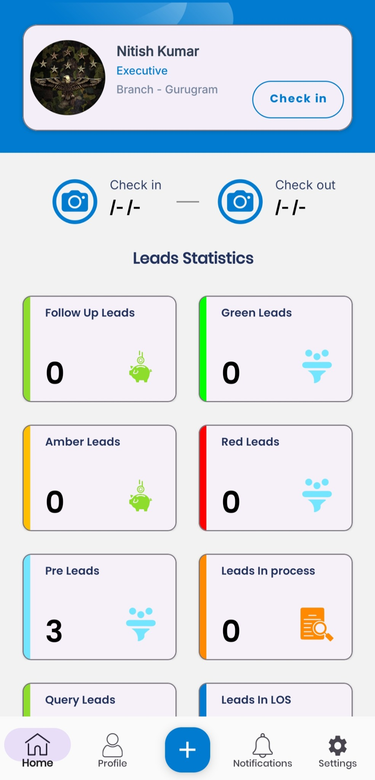
After launching the LeadTrack App and logging in with your credentials, the Home screen displays your profile card (name, role, and branch). To begin your day, tap Check In (located to the right of your profile) and allow the app to capture a photo for verification. The app will then show your check-in time under Check in and change the button to Check Out. At the end of your day, tap Check Out and capture a photo to record your departure time. 1. Open and log in: Launch the app and enter your user credentials. Upon successful login, you will see your profile card on the Home screen.
- Check In: Tap the Check In button. The camera will open; take a clear photo of yourself or your surroundings as prompted. Confirm the photo to complete check-in.
- Verify check-in: After a successful check-in, the screen will display your photo and the current time under
Check in. The Check Out button will appear.

- Check Out (end of day): When you finish work, tap the Check Out button and capture a photo. This logs your check-out time and completes your attendance record.

Navigating the Dashboard
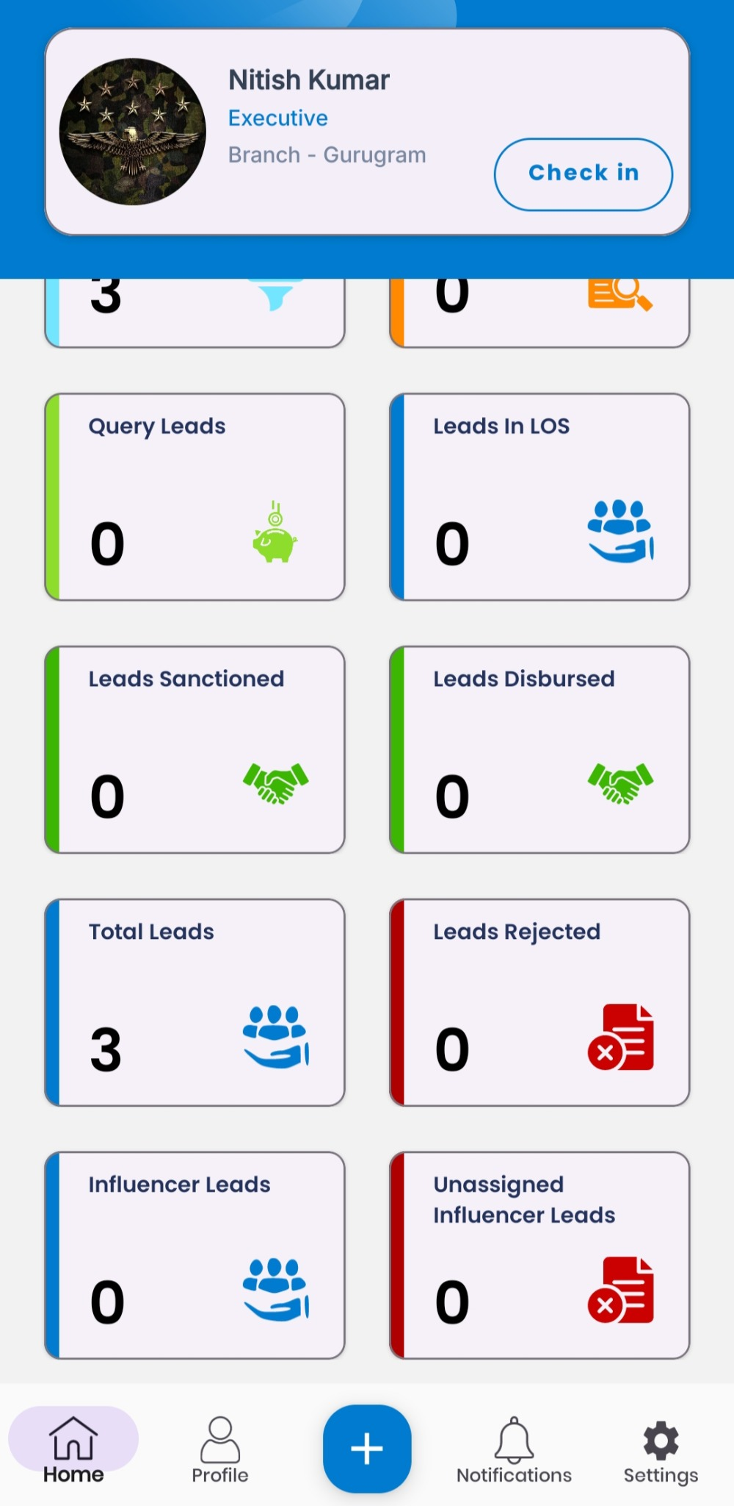
The Home screen includes a Leads Statistics section showing key metrics at a glance. Each metric is displayed in a colored panel with an icon. Use these to monitor your pipeline: - Follow Up Leads: Number of leads flagged for follow-up contact (green icon).
  - Green Leads: High-priority or high-probability leads (green color-coded funnel icon).
  - Amber Leads: Medium-priority leads (yellow icon).
  - Red Leads: Low-priority or problem leads (red icon).
  - Pre Leads: Preliminary inquiries or pre-qualified leads (blue icon).
  - Leads In Process: Leads currently being processed by the system (orange icon with document).
  - Query Leads: Leads with pending queries or issues (light green icon).
  - Leads in LOS: Leads in the loan origination system or active processing stage (blue icon with team).
  - Leads Sanctioned: Leads approved for loans (green handshake icon).
  - Leads Disbursed: Leads for which funds have been disbursed (green handshake icon).
  - Total Leads: Total number of leads in the system (blue group icon). The example shows Total Leads = 3.
  - Leads Rejected: Leads that have been declined (red document icon).
  - Influencer Leads: Leads generated through influencers (blue group icon).
  - Unassigned Influencer Leads: Influencer-generated leads not yet assigned (red document icon). These metrics update dynamically as you enter and update leads in the app.

Adding New Leads and Influencers
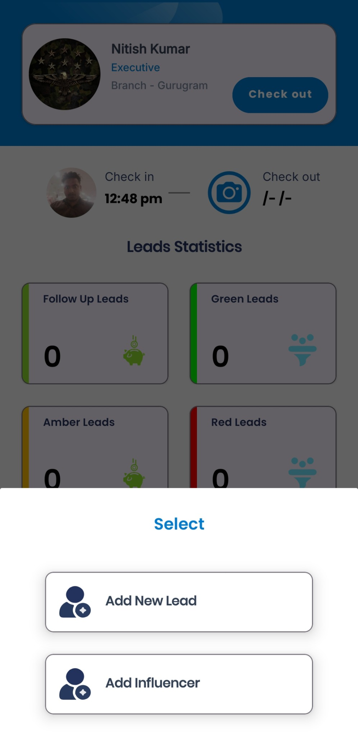
To add a lead, tap the blue + button at the bottom center of any screen. A Select menu will pop up. Choose Add New Lead to create a standard customer lead or Add Influencer to log a lead from an influencer. Both options start a similar entry process: - Step 1: On the Home screen, tap the + (Add) button (blue circle with plus sign).
  - Step 2: In the Select menu that appears, tap Add New Lead (person icon) to proceed with a new lead, or
Add Influencer to log an influencer-based lead.
  - Step 3: The app will navigate to the Visit Detail form to begin capturing information about your visit and the lead.

Completing the Visit Detail Form
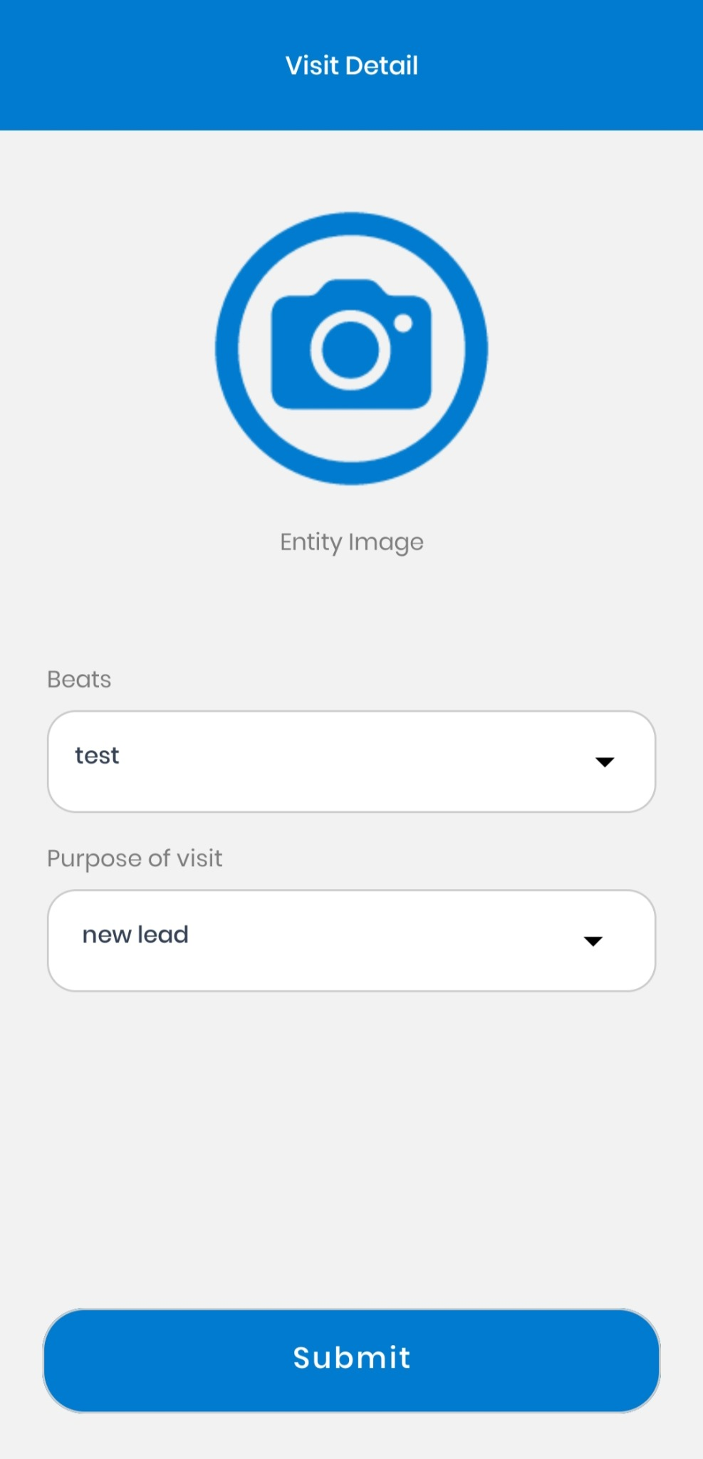
After selecting Add New Lead, you land on the Visit Detail screen. Complete the form as follows: - Entity Image: Tap the camera icon or image placeholder to take or upload a photo of the place or person visited. This serves as visual verification of the visit.
  - Beats: Tap the dropdown to select your sales area or route (for example, "test" in the screenshot). This categorizes where the visit took place.
  - Purpose of Visit: Tap the dropdown to select why you are visiting (e.g. New Lead, Follow Up, etc.). In this example, "new lead" is selected.
  - Submit: When all fields are filled, tap the Submit button at the bottom. This saves the visit details and advances you to the lead entry process. 1. Capture Photo: Ensure the photo clearly shows the visit entity or yourself. Confirm and save the image.
- Select Beat: Choose the appropriate sales beat or region for this visit.
- Choose Purpose: Indicate the reason for the visit from the list.
- Submit: Tap Submit to confirm. The app will validate entries and proceed to the next screen.

Submitting a New Lead
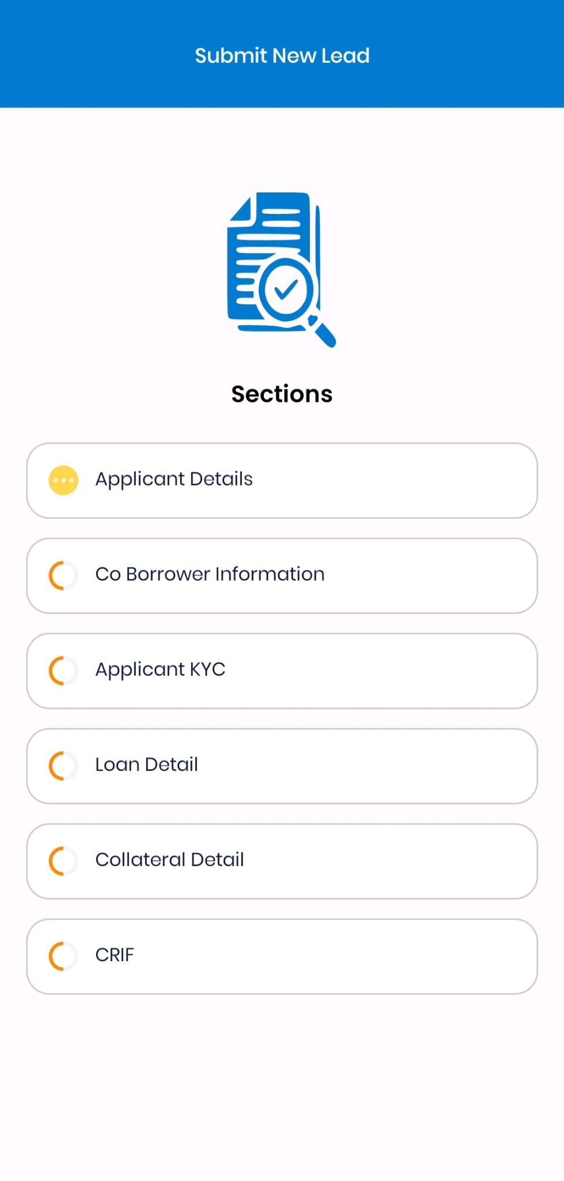
You will now see the Submit New Lead screen with multiple Sections to complete. Tap each section in order and fill in the required details. The app shows a progress icon next to incomplete sections (yellow/ orange circle). Complete all sections fully before final submission: - Applicant Details: Enter the lead’s personal information (name, contact number, address, etc.).
  - Co-Borrower Information: If applicable, enter information for a co-applicant or spouse. If none, leave blank or indicate None.
  - Applicant KYC: Upload or capture identity documents (such as ID proof, address proof) as required. Ensure the images are clear and legible.
  - Loan Detail: Specify the loan requirements, including type (home, auto, etc.), desired amount, and tenure.
  - Collateral Detail: Provide details of any collateral or security offered by the applicant (property, vehicle, etc.).
  - CRIF: Attach or retrieve the applicant’s credit report or score (often a PDF or system-fetched data).

Once you have filled all sections (all icons change from orange to solid or a check mark), tap Submit at the top or bottom of the screen to send the new lead for processing. - Step-by-Step: For each section, enter all mandatory fields. You can tap Next or the section name to navigate. Review your entries for accuracy.
  - Final Submission: After completing CRIF and ensuring all sections are complete, use the Submit action. You should see a confirmation message (e.g., “Lead submitted successfully”). If any required information is missing, the app will highlight the specific fields or prompt an error.

Dashboard Metrics Description
The dashboard’s color-coded panels help you quickly assess your workload and performance: - Green Leads (green): High-priority leads likely to convert.
  - Amber Leads (yellow): Medium-priority leads needing more follow-up.
  - Red Leads (red): Low-probability or stalled leads.
  - Follow Up Leads: Leads marked for another contact attempt.

  - Query Leads (light green): Leads awaiting response to specific questions.
  - Pre Leads (blue): New inquiries or partially qualified leads.
  - Leads in Process (orange): Leads currently being processed by the loan system.
  - Leads in LOS (blue): Leads actively in the loan origination workflow.
  - Leads Sanctioned/Disbursed (green): Counts of approved and funded loans.
  - Leads Rejected (red): Leads that did not meet criteria.
  - Influencer Leads (blue): Leads from influencers, and Unassigned Influencer Leads (red): those not yet assigned to an executive.

Use this dashboard daily to track progress. Tap any metric card (if interactive) to view the list of associated leads in that category.

Error Handling and Confirmation
    - If you attempt to submit a form with missing mandatory information, the app will display an error message (for example, “Please fill all required fields”) and highlight the missing fields in red. Complete these fields to proceed.
    - Confirm each action: after Check In/Out and final Lead submission, watch for success notifications
or toast messages confirming the action. If a submission fails, try again or check your network connection.
    - Always ensure photos are clear and all text fields are filled before submitting to avoid rejection.

PowerPoint Presentation Outline
    - Slide 1: Title – “LeadTrack App SOP Overview”

    - Overview of app purpose and training objectives.

    - Slide 2: Login & Check-In

    - Steps to open app and log in.
    - Tap Check In and take a verification photo.
    - Verify your check-in time appears.

    - Reminder to Check Out with photo at end of day.

    - Slide 3: Home Dashboard

    - Overview of Home screen with profile info.
    - Leads Statistics panels visible.
    - Shows color-coded lead categories (Green, Amber, Red, etc.).

    - Example: “Total Leads = 3”.

    - Slide 4: Dashboard Metrics

    - Follow Up Leads: leads needing follow-up.
    - Green/Amber/Red Leads: status categories (high/medium/low priority).
    - Pre Leads: new inquiries.
    - Query Leads: with questions pending.
    - Leads in Process/LOS: pipeline stages.
    - Leads Sanctioned/Disbursed: loan approval stats.
    - Influencer Leads: from influencers.

    - Slide 5: Adding Leads/Influencers

    - Tap + button on Home.
    - Select Add New Lead or Add Influencer.

    - Begin the visit and lead entry process.

    - Slide 6: Visit Detail Form

    - Entity Image: Capture a photo.
    - Beats: Select your sales area/route.
    - Purpose of Visit: Choose reason (New Lead, etc.).
    - Tap Submit to save and proceed.

    - Slide 7: Submit New Lead (Sections)

    - Complete sections in order:
      - Applicant Details (personal info)
      - Co-Borrower Info (if any)
      - Applicant KYC (ID docs)
      - Loan Detail (amount, term)
      - Collateral (security info)
      - CRIF (credit report)
    - Fill all required fields; all sections show a check when done.

    - Slide 8: Final Submission & Errors

    - Tap Submit to send the lead.
    - Watch for success confirmation.
    - If errors, the app will highlight missing fields.

    - Ensure all information and photos are complete.

    - Slide 9: Summary

    - Daily routine: Login → Check In → Update Leads → Check Out.
    - Use dashboard for tracking.

    - Follow SOP to capture all details for each lead.
    - Contact support if you encounter persistent errors.

